**AUGUST 2021**

**ANOTHER RECORD HIGH**

*While Spokane County's median home price surged to another record high in July, a slight uptick in inventory and cooling sales may be signs of a market beginning to normalize, local Realtors say.*

*Spokane County's median home price spiked to $395,000 in July, up 31% compared to the $301,509 median in July 2020, according to data from the Spokane Association of Realtors.*

**

The article continues in ***The Spokesman-Review*** [**online here**](https://www.spokesman.com/stories/2021/aug/11/spokane-countys-median-home-price-sets-new-record-/).

|  |  |  |
| --- | --- | --- |
| |  | | --- | | **Forms Revisions** | |  |       **Effective Next Week!**  **Monday, August 16th**    **Revisions to the Residential Landlord Tenant Act & Seller Disclosure Act**  Legal Bulletin 220 summarizes revisions to the Residential Landlord Tenant Act (RCW 59.18) ("RLTA") and related changes to NWMLS's lease and rental forms.  The bulletin provides general information about the revisions to the RLTA and does not address specific scenarios that may arise with the landlord/tenant relationship.  If a landlord or tenant has questions about their rights or obligations under the RLTA, you should advise them to speak with an attorney.  This bulletin also summarizes revisions to the Seller Disclosure Act (RCW 64.06) and the related changes to the Seller Disclosure Statement - Improved Property (Form 17) and the Seller Disclosure Statement - Unimproved Property (Form 17C).   Legal Bulletin 220 and SAMPLE versions of the revised forms are linked below for review purposes - in both clean and redline formats:  **Legal Bulletin 220**  <http://members.nwmls.com/library/content/legalbulletins/LB_220/LB_220.pdf>  **Form Revision: Redline**  <http://members.nwmls.com/library/content/legalbulletins/LB_220/FormsRevision_821_Redlines.pdf>  **Form Revision: Samples**  <http://members.nwmls.com/library/content/legalbulletins/LB_220/FormsRevision_821_Samples.pdf>  The revised forms are currently available as SAMPLE forms for review purposes only.  The forms will be published for use on TransactionDesk and Xpress Forms on **Monday, August 16th**. |

|  |
| --- |
| **DOL Fee Increase** |
|     The Washington State Department of Licensing (DoL) recently announced it will be increasing its real estate license fees in late August or early September.  This announcement has caused some questions.  To answer them, the DoL has released a Frequently Asked Questions handout for real estate brokers to address common questions, such as why they are raising fees and when these fee increases go into effect.    That document, pictured above, is [**online here**](https://files.constantcontact.com/4fd76739001/144c96a1-7366-4ea9-8aea-e326a9f181f3.pdf).    If brokers have further questions, call the Real Estate unit at the Department of Licensing at **360.664.6500** or email  [**realestate@dol.wa.gov**](mailto:realestate@dol.wa.gov)        This week's **Housing Advocacy** question:    ***Why are home prices going up so fast in Spokane?***    Watch this one-minute video for the answer:       |  | | --- | | [Advocacy min 1](https://www.spokanerealtor.com/prices/) | | Advocacy min 1 |           This video is one in a series of SAR Housing Advocacy minutes currently appearing on various social media platforms to select viewers in the Spokane area.    Members are invited and encouraged to share this video on their own social media channels and websites to help continue the housing conversation in our area.        **Fees Increased July 26th**    *Buying a home is about to get a little bit more expensive.*    *On July 26, recording fees at the Spokane County Auditor's Office will increase $100.*    *It's a change brought on by House Bill 1277, which the state legislature passed this year.*    *The purpose of the bill, and the fee increase it requires, is to generate more money for affordable housing and ending homelessness.*        Read this article in ***The Spokesman-Review***, [**online here**](https://www.spokesman.com/stories/2021/jul/20/buying-a-house-in-spokane-county-itll-cost-an-extr/).            **The county warns that documents received without the proper fee on and after July 26th will be returned to the submitter.**    Read more about this on the Spokane County website, [**online here**](https://www.spokanecounty.org/CivicAlerts.aspx?AID=3506). |

**C2EX**

***Washington REALTORS® challenge - Which Association Will Win?***

**C2EX Contest Runs Through August 31**

The local association with the highest percentage of increase of C2EX completions based on the local association size by August 31 will win a ***FREE***WR class!

This includes:

* Instructor fees
* Certificate fees
* Location fees

**Commitment to Excellence** empowers you to enhance and showcase your high level of professionalism.

It gives you an advantage in our highly competitive market and shows consumers you're committed to conducting business at the highest standard.

It looks like we have 147 SAR Members that have started their C2EX training, with 16 SAR Members that have completed their C2EX training.

Congrats to those 16 members!

|  |  |  |  |  |  |  |  |  |  |  |  |  |  |  |  |  |  |  |  |  |  |  |  |  |  |  |  |  |  |  |  |  |  |
| --- | --- | --- | --- | --- | --- | --- | --- | --- | --- | --- | --- | --- | --- | --- | --- | --- | --- | --- | --- | --- | --- | --- | --- | --- | --- | --- | --- | --- | --- | --- | --- | --- | --- |
| |  |  | | --- | --- | | Anne | Anderson | | Bree | Campana | | Grace | Chiquette | | Tom | Clark | | Kim | Cooper | | Julie | Cope | | Cynthia | Gustafson | | Steve | Hagen | | |  |  | | --- | --- | | Kristy | Hamby | | Tom | Hormel | | Eric | Johnson | | Karene | Loman | | Gina | Mosey | | Miranda | O'Callaghan | | Jennifer | Shupe | | Lexi | Witherwax | |

We hope you'll be one of those who will complete your training by the end of August.

Bonus - WR will send a free lapel pin to all WR members who complete C2EX!

Download the poster (pictured above) [**online here**](https://files.constantcontact.com/4fd76739001/53a12855-9af7-47ba-9562-bfac6777831a.pdf).

Get started on your C2EX [**online here**](https://www.c2ex.realtor/).

**Open Enrollment Open Now!**

**Closes Sunday, August 15th**

The current open enrollment period for health insurance closes this weekend.

Open Enrollment is a period during which one may freely enroll in or change one's selection of a health insurance plan or other benefit program that is ordinarily subject to restrictions.

Explore your options for health insurance for yourself and your family within the REALTORS® Insurance Place [**online here**](https://www.realtorsinsurancemarketplace.com/products/member-health-insurance-exchange/).

**JULY MARKET STATISTICS**

Closed sales of single-family homes on less than one acre including condominiums totaled 807 for July 2021. Compared to July last year, closed sales were down 4.4%, 807 v. 844. The average sales price for closed sales was $417,136 an increase of 26.6% over July last year when the average closed sales price was $329,501. The median closed sales price increased 31% over July last year, $395,000 v. $301,509.

Year to date closed sales through July are up 5.3% compared to the same period last year, 4,472 closed sales this year compared to 4,246 over the same period last year. The average closed sales price through July is $392,140 up 27.8% over July’s year to date average closed ales price of $306,913. The year-to-date median sales price through July is up 25.8% compared to last year, $360,000 v. $286,000.

Inventory is seeing a slight improvement. Inventory as of 8/4/21 revealed 374 single family homes on less than one acre including condominiums on the market, an increase of 31.7% from last month, however, compared to last year, inventory is down 28.1%. New construction sales reported to the SAR/MLS slowed somewhat with 80 closed sales reported. Year to date, new construction closed sales are up 2.3%, 584 v. 571.

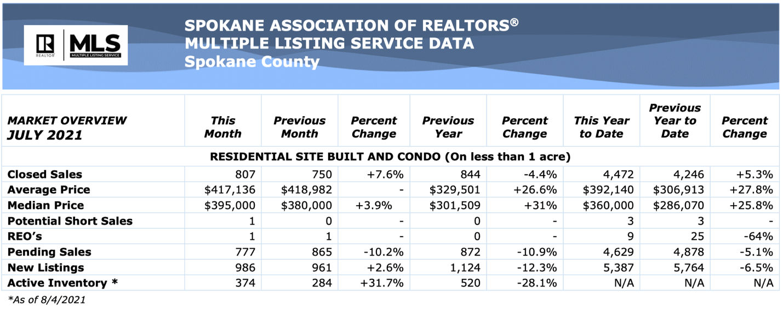

The above is an excerpt of the Spokane Association of REALTORS’® **July 2021** Residential Market Activity Report. Access to the full report each month is a benefit of your association membership. See the full report online here (after you log in to the member portal): [**https://www.spokanerealtor.com/mls/market-activity-mls-statistics**](https://www.spokanerealtor.com/mls/market-activity-mls-statistics)

**JULY LOCKBOX STATISTICS**

